For those who are using Google Colab, please adhere to the following steps:

1. Sign in using your Google account and navigate to the **Google Colab** website:
2. The interface displayed below will appear:



1. Select **Open Colab** as shown below:



1. The following instance will appear, here you can **Upload** an existing Jupyter notebook andwork. You can also create a **New notebook** as shown below:

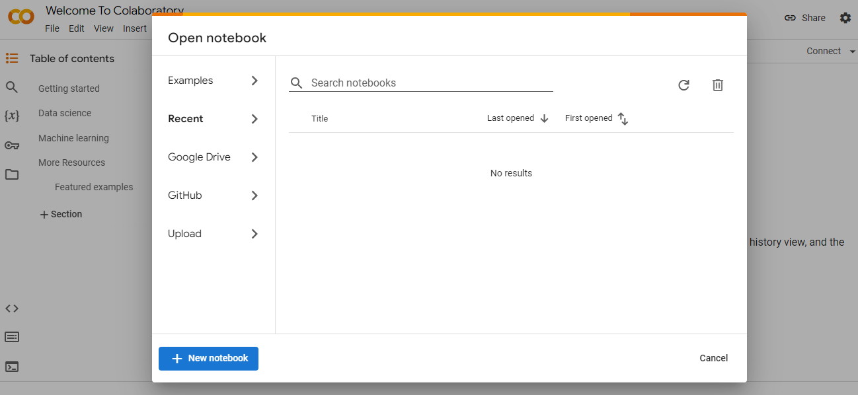

1. For dataset integration in the Google Colab environment, use one of the following methods:

* Directly from your local system, through the Google Colab’s left panel
* From Google Drive, via the same panel
* Utilizing the **wget** command for online sources